Practical 12

Aim
To build an interactive real-time web application using JavaScript and jQuery with DOM manipulation, event handling, browser storage, and AJAX integration.

Software Required
- Visual Studio Code or another code editor
- Live Server extension (recommended)
- Modern web browser with Developer Tools
- Internet connection for the jQuery CDN and AJAX API

Theory

DOM Manipulation
The Document Object Model (DOM) represents an HTML page as a tree of elements. JavaScript can read, create, update and remove these elements without reloading the page. In this application, task rows and dashboard statistics are regenerated whenever task data changes.

jQuery and Event Handling
jQuery is a JavaScript library that simplifies element selection, event handling, effects and AJAX calls. The $() function selects elements. The on() method responds to user actions such as click, submit, change and input. Event delegation lets dynamically created task buttons work correctly.

Browser Storage
localStorage saves key–value pairs in the browser and retains them after refreshing or closing the tab. Task objects are converted to JSON text using JSON.stringify() and read back using JSON.parse(). The stored information is local to that browser and origin.

AJAX Integration
AJAX (Asynchronous JavaScript and XML) allows a webpage to request server data without a full page reload. Modern AJAX commonly exchanges JSON. Here, $.ajax() requests a random quotation from the DummyJSON API and updates the quotation card when the response arrives. If the request fails, a built-in fallback quotation appears.

Real-Time User Interface
The dashboard updates immediately in response to events. Total, completed and pending counts, progress percentage, task lists and filters are recalculated after each change. This is event-driven real-time interaction; it does not require a continuously connected server.

Responsive Design
CSS Grid, Flexbox and media queries rearrange the dashboard for smaller screens, allowing the same application to work on desktop and mobile.

Implementation Overview
The TaskFlow web app is divided into three main source files. It begins with three sample tasks on the first visit. Subsequent changes are stored in localStorage.
File | Responsibility
index.html | Page structure: header, statistics, task form, task list, filters and AJAX quotation card.
style.css | Responsive layout, task priority badges, progress bar, typography and mobile styling.
app.js | jQuery event handlers, dynamic DOM updates, localStorage, search/filter, and AJAX request.

Output

File Path - D:\Symbiosis University\Sem 5\JavaScript\JavaScript VSCode\Practical 12 VA\index.html
24070521271_SnehaShah

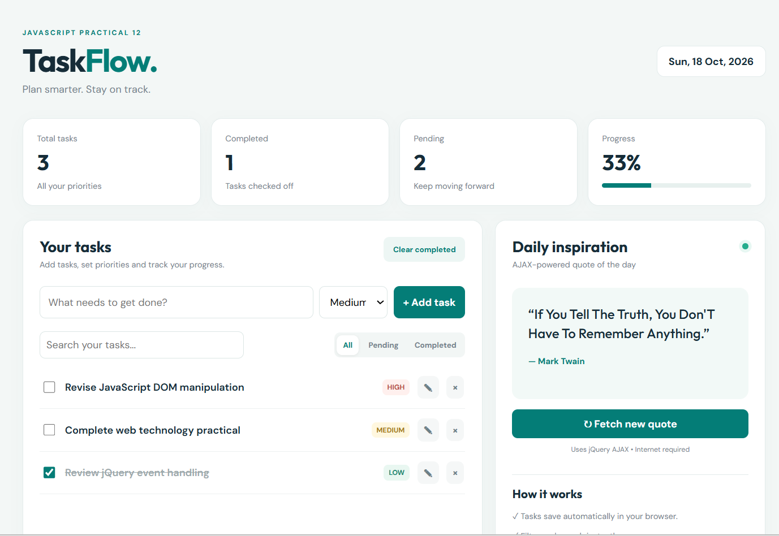

Result
The TaskFlow application successfully supported adding, editing, deleting, completing, searching and filtering tasks. Dashboard values updated immediately, task data persisted after page refresh through localStorage, and quotations were fetched asynchronously through jQuery AJAX without reloading the page. The interface adjusted to different screen sizes.

